What is Graph and Graph Theory?

Graph

A graph is a pictorial and mathematical representation of a set of objects where some pairs of objects are connected by links.

The interconnected objects are represented by points termed as vertices or nodes and the links that connect the vertices are called edges or arcs or lines.

In other words, a graph is an ordered pair **G = (V, E)** where,

* **G** specifies the graph.
* **V** is the vertex-set whose elements are called the vertices, or nodes of the graph. This set is often denoted by **V(G)** or just **V**.
* **E** is the edge-set whose elements are called the edges, or connections between vertices of the graph. This set is often denoted by **E(G)** or just **E**.

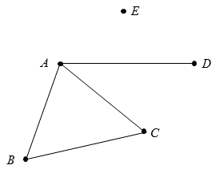

In the above graph,

1. V = {A, B, C, D, E}
2. E = {AB, BC, CA, AD}

Graph Theory

Graph theory is the sub-field of mathematics and computer science which deals with graphs, diagrams that contain points and lines and which often pictorially represents mathematical truths.

In short, graph theory is the study of the relationship between edges and vertices.

# **Fundamental Concepts**

Some of the basic fundamental concepts of **graph theory** are:

## 1. Point

A **point** is a particular position that is located in a space. Space can be one-dimensional, two-dimensional or three-dimensional space. A dot is used to represent a point in graph and it is labeled by alphabet, numbers or alphanumeric values.

### **Example**

Fundamental Concepts

Here, dot is a point labeled by 'p'.

## 2. Line

Two points are connected to each other through a **line**. A **line** is a connection between two points. It is represented by a solid line.

### **Example**

Fundamental Concepts

Here, 'A' and 'B' are the points and links between two points is called a line.

## 3. Vertex

A **vertex** is a synonym of point in graph i.e. one of the points on which the graph is defined and which may be connected by lines/edges is called a vertex.

Vertex is also called "node", "point" or "junction". A vertex is denoted by alphabets, numbers or alphanumeric value.

### **Example**

Fundamental Concepts

Here, point is the vertex labeled with an alphabet 'v'.

## 4. Edge

**Edge** is the connection between two vertices. Each edge connects one vertex to another vertex in the graph. Without a vertex, an edge cannot be formed. It is also called line, branch, link or arc.

Edge can either be **directed** or **undirected**. A directed edge is the edge which points from one vertex to another, and an undirected edge has no direction.

If there is a directed edge from vertex A to B, and a directed edge from B to A, this would essentially be equivalent to an undirected edge connecting A and B.

### **Example**

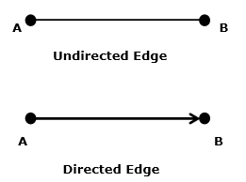

Here, **'A' and 'B'** are the **vertices** and the link 'AB' between them is called an **edge**.

Graph

**Graph** specifies to a "function graph" or "graph of a function" i.e. a **plot**.

In mathematics terminology, a graph is a collection of points and lines connecting some (possibly empty) subset of them.

**A graph G is defined as G = {V, E} where V is a set of all vertices or points and E is the set of all edges in the graph.**

Example 1



In the above example, A, B, C, D and E are the vertices of the graph and AB, BC, CA and AD are the edges of the graph.

Example 2

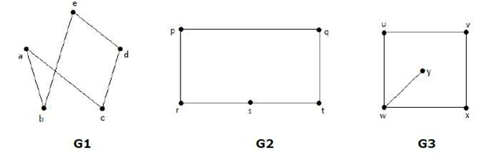

In the above example, G1, G2 and G3 are graphs.

# **Types of Graphs**

Though, there are a lot of different types of graphs depending upon the number of vertices, number of edges, interconnectivity, and their overall structure, some of such common types of graphs are as follows:

## 1. Null Graph

A **null graph** is a graph in which there are no edges between its vertices. A null graph is also called empty graph.

### **Example**

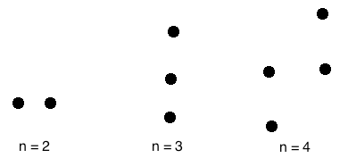

A null graph with n vertices is denoted by Nn.

## 2. Trivial Graph

A **trivial graph** is the graph which has only one vertex.

### **Example**

Types of Graphs

In the above graph, there is only one vertex 'v' without any edge. Therefore, it is a trivial graph.

## 3. Simple Graph

A **simple graph** is the undirected graph with **no parallel edges** and **no loops**.

A simple graph which has n vertices, the degree of every vertex is at most n -1.

### **Example**

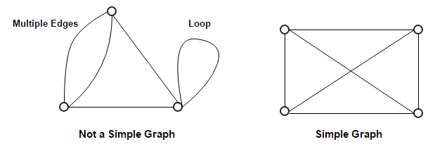

In the above example, First graph is not a simple graph because it has two edges between the vertices A and B and it also has a loop.

Second graph is a simple graph because it does not contain any loop and parallel edges.

## 4. Undirected Graph

An **undirected graph** is a graph whose edges are **not directed**.

### **Example**

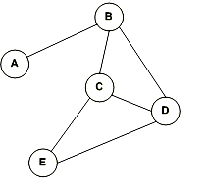

In the above graph since there is no directed edges, therefore it is an undirected graph.

## 5. Directed Graph

A **directed graph** is a graph in which the **edges are directed** by arrows.

Directed graph is also known as **digraphs**.

### **Example**

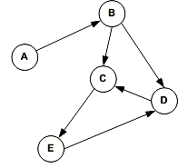

In the above graph, each edge is directed by the arrow. A directed edge has an arrow from A to B, means A is related to B, but B is not related to A.

## 6. Complete Graph

A graph in which every pair of vertices is joined by exactly one edge is called **complete graph**. It contains all possible edges.

A complete graph with n vertices contains exactly nC2 edges and is represented by Kn.

### **Example**

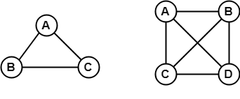

In the above example, since each vertex in the graph is connected with all the remaining vertices through exactly one edge therefore, both graphs are complete graph.

## 7. Connected Graph

A **connected graph** is a graph in which we can visit from any one vertex to any other vertex. In a connected graph, at least one edge or path exists between every pair of vertices.

### **Example**

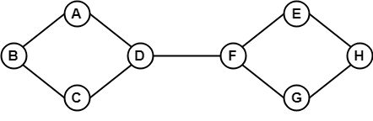

In the above example, we can traverse from any one vertex to any other vertex. It means there exists at least one path between every pair of vertices therefore, it a connected graph.

## 8. Disconnected Graph

A **disconnected graph** is a graph in which any path does not exist between every pair of vertices.

### **Example**

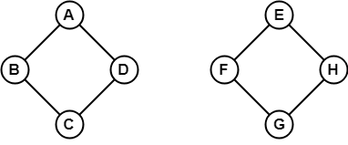

The above graph consists of two independent components which are disconnected. Since it is not possible to visit from the vertices of one component to the vertices of other components therefore, it is a disconnected graph.

## 9. Regular Graph

A **Regular graph** is a graph in which degree of all the vertices is same.

If the degree of all the vertices is k, then it is called k-regular graph.

### **Example**

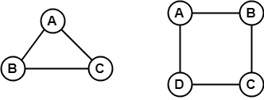

In the above example, all the vertices have degree 2. Therefore they are called 2- **Regular graph**.

## 10. Cyclic Graph

A graph with 'n' vertices (where, n>=3) and 'n' edges forming a cycle of 'n' with all its edges is known as **cycle graph**.

A graph containing at least one cycle in it is known as a **cyclic graph**.

In the cycle graph, degree of each vertex is 2.

The cycle graph which has n vertices is denoted by Cn.

### **Example 1**

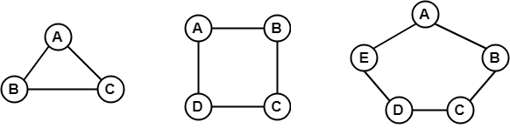

In the above example, all the vertices have degree 2. Therefore they all are cyclic graphs.

### **Example 2**

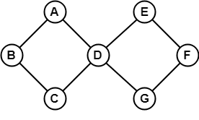

Since, the above graph contains two cycles in it therefore, it is a cyclic graph.

## 11. Acyclic Graph

A graph which does not contain any cycle in it is called as an **acyclic graph**.

### **Example**

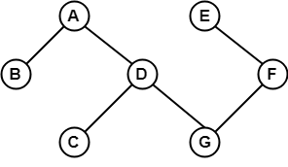

Since, the above graph does not contain any cycle in it therefore, it is an acyclic graph.

## 12. Bipartite Graph

A **bipartite graph** is a graph in which the vertex set can be partitioned into two sets such that edges only go between sets, not within them.

A graph G (V, E) is called bipartite graph if its vertex-set V(G) can be decomposed into two non-empty disjoint subsets V1(G) and V2(G) in such a way that each edge e ∈ E(G) has its one last joint in V1(G) and other last point in V2(G).

The partition V = V1 ∪ V2 is known as bipartition of G.

### **Example 1**

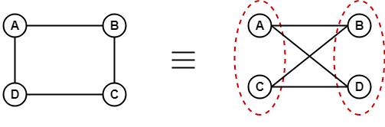

### **Example 2**

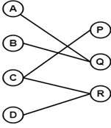

## 13. Complete Bipartite Graph

A **complete bipartite graph** is a bipartite graph in which each vertex in the first set is joined to each vertex in the second set by exactly one edge.

A complete bipartite graph is a bipartite graph which is complete.

Complete Bipartite graph =   Bipartite graph + Complete graph

### **Example**

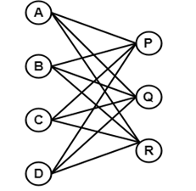

The above graph is known as K4,3.

## 14. Star Graph

A star graph is a complete bipartite graph in which n-1 vertices have degree 1 and a single vertex have degree (n -1). This exactly looks like a star where (n - 1) vertices are connected to a single central vertex.

A star graph with n vertices is denoted by Sn.

### **Example**

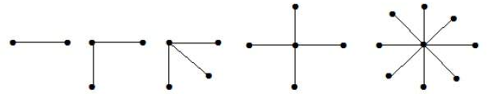

In the above example, out of n vertices, all the (n-1) vertices are connected to a single vertex. Hence, it is a star graph.

## 15 Weighted Graph

A weighted graph is a graph whose edges have been labeled with some weights or numbers.

The length of a path in a weighted graph is the sum of the weights of all the edges in the path.

### **Example**

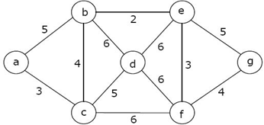

In the above graph, if path is a -> b -> c -> d -> e -> g then the length of the path is 5 + 4 + 5 + 6 + 5 = 25.

## 16. Multi-graph

A graph in which there are multiple edges between any pair of vertices or there are edges from a vertex to itself (loop) is called a **multi - graph**.

### **Example**

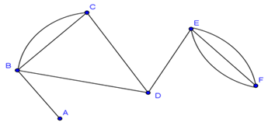

In the above graph, vertex-set B and C are connected with two edges. Similarly, vertex sets E and F are connected with 3 edges. Therefore, it is a multi graph.

## 17. Planar Graph

A **planar graph** is a graph that we can draw in a plane in such a way that no two edges of it cross each other except at a vertex to which they are incident.

### **Example**

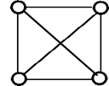

The above graph may not seem to be planar because it has edges crossing each other. But we can redraw the above graph.

The three plane drawings of the above graph are:

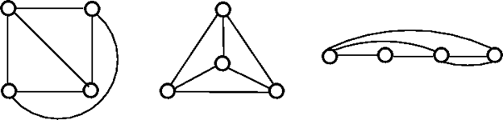

The above three graphs do not consist of two edges crossing each other and therefore, all the above graphs are planar.

## 18. Non - Planar Graph

A graph that is not a planar graph is called a non-planar graph. In other words, a graph that cannot be drawn without at least on pair of its crossing edges is known as non-planar graph.

### **Example**

